**B.Nikhil**

**192111054**

**OBJECT ORIENTED ANALYSIS AND DESIGN FOR SOFTWARE DESIGN(CSA1176)**

LAB DAY-03

**1.Hospital Management System**

**Use Case Diagram**

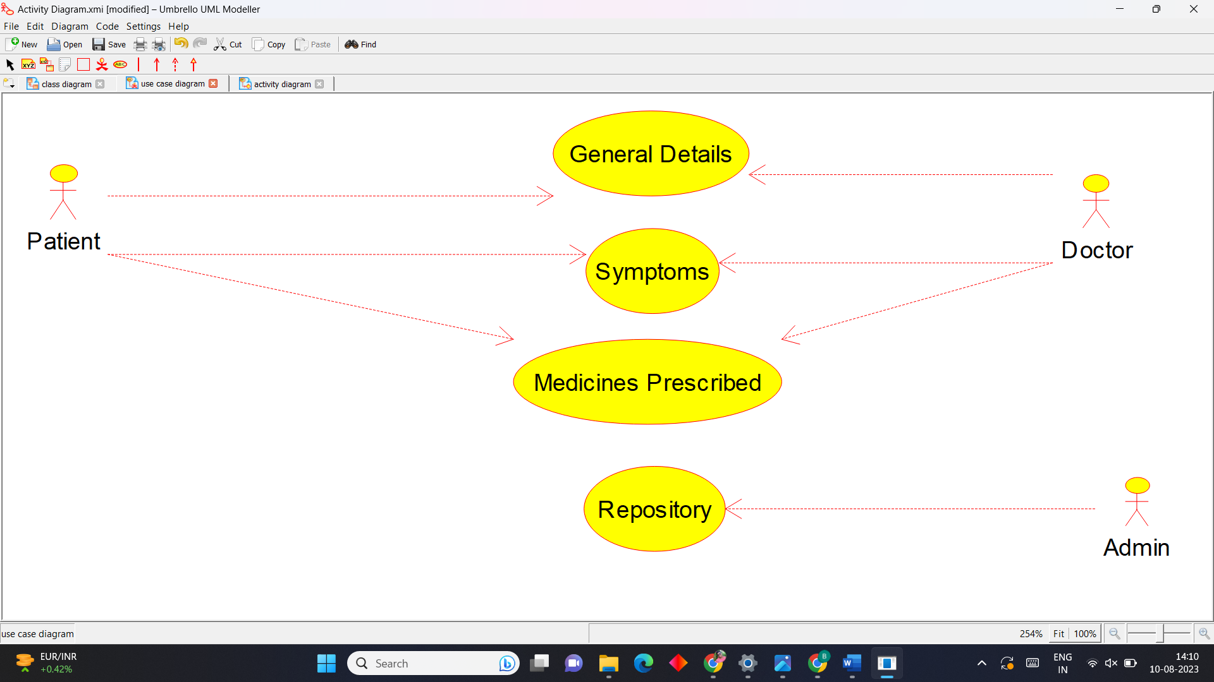

**Activity Diagram**

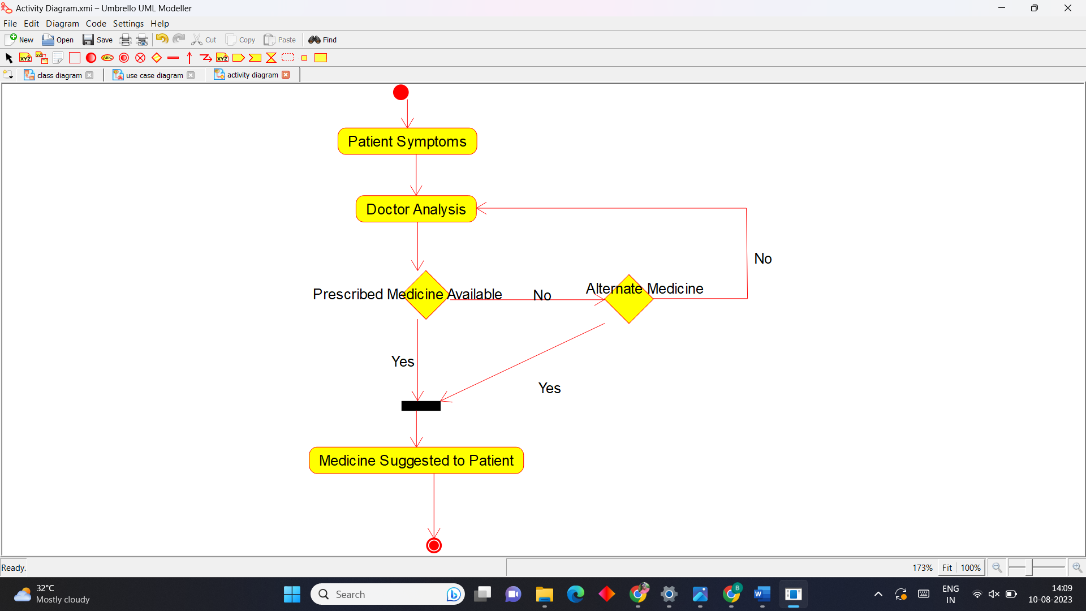

**Sequence Diagram**



**2.Online Insurance Processing System.**

**Use Case Diagram**

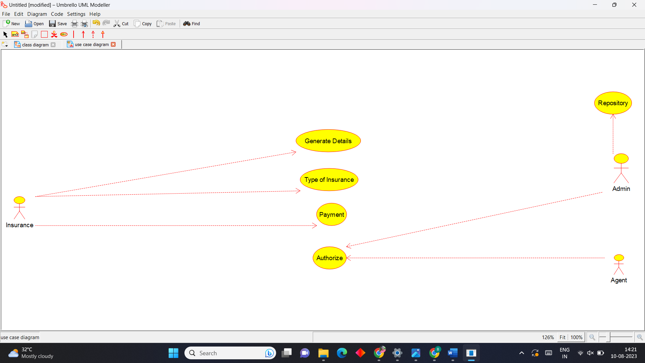

**Activity Diagram**

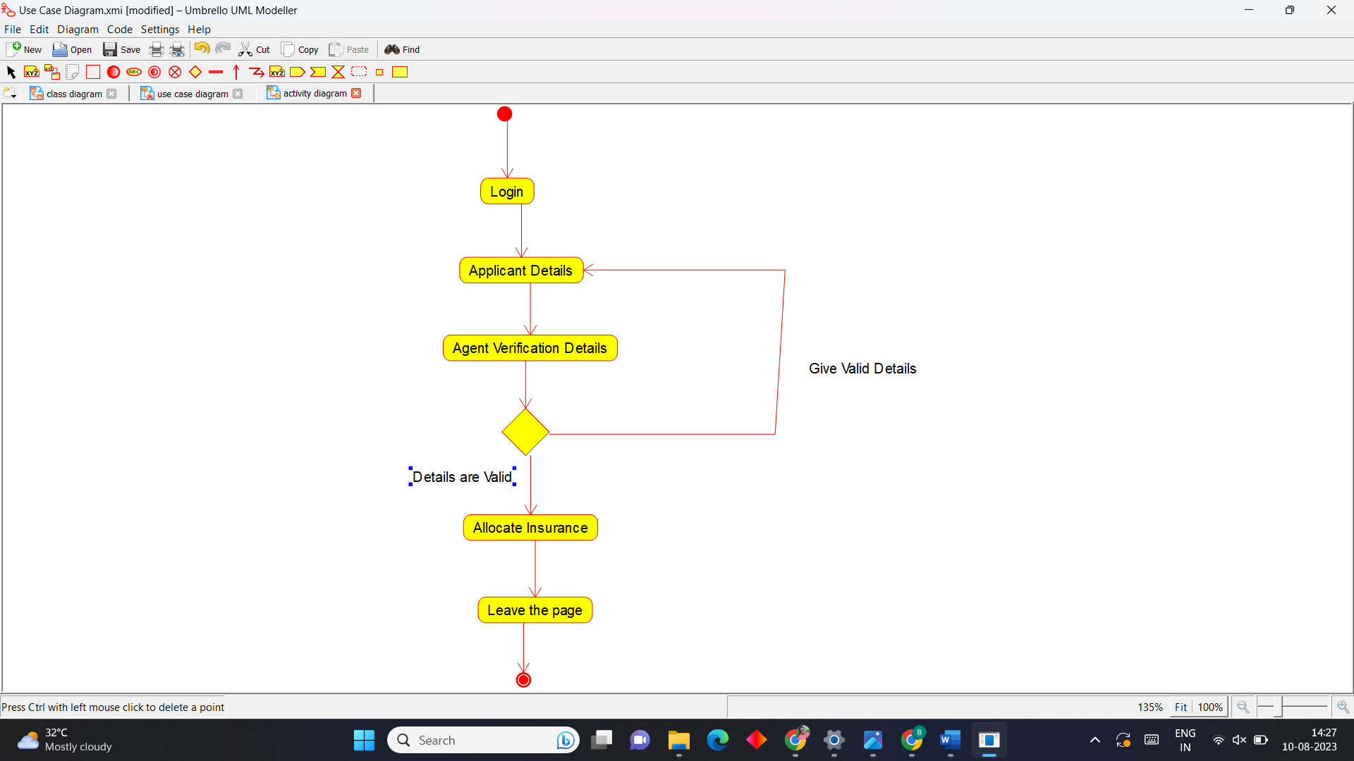

**Sequence Diagram**



**3.Online Shopping System**

**Use Case Diagram**

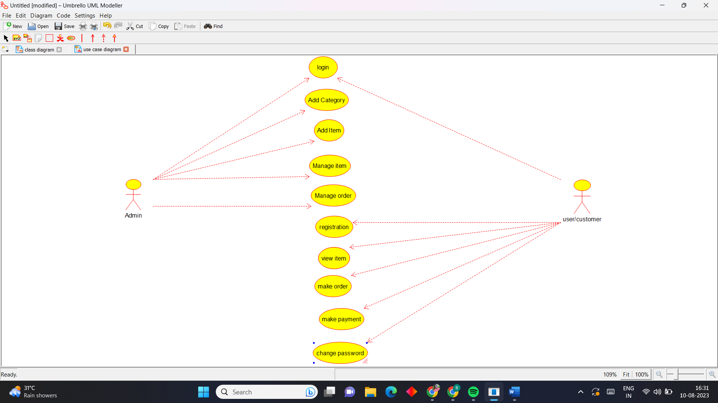

**Activity Diagram**

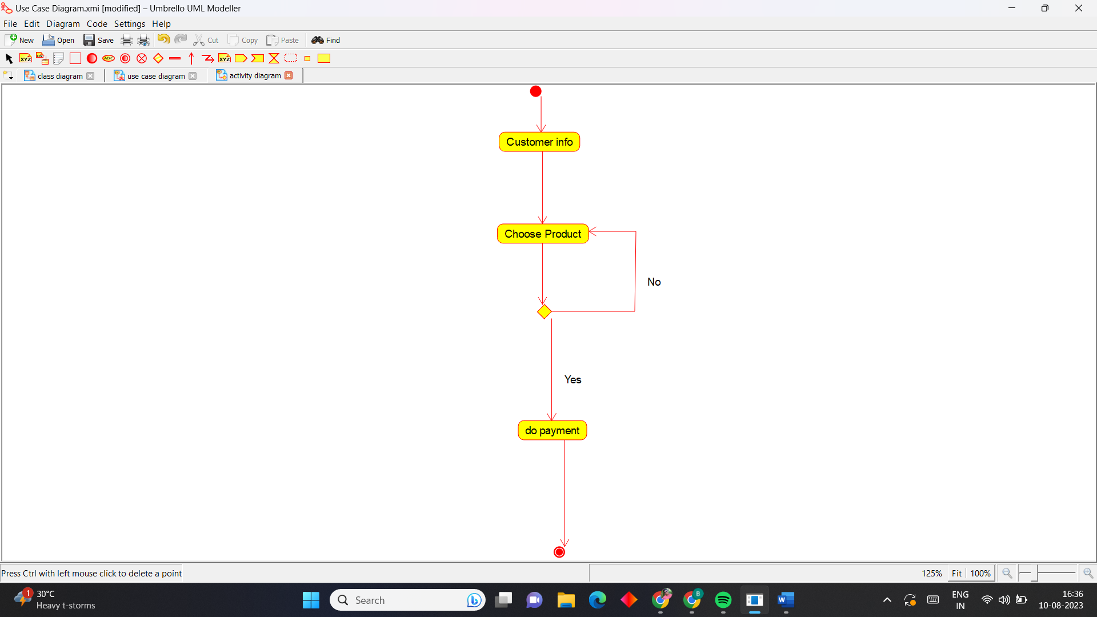

**Sequence Diagram**

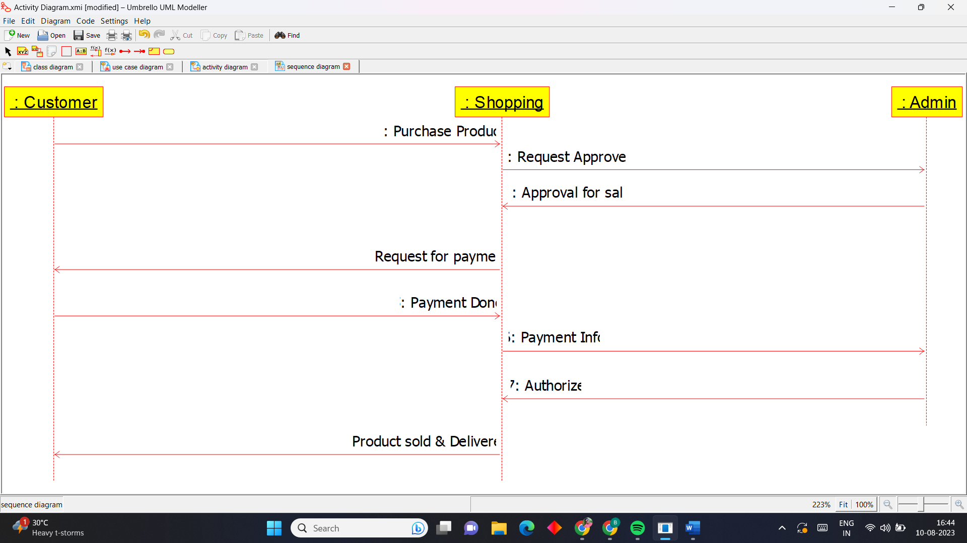

**4.Online Stock Market System.**

**Use Case Diagram**

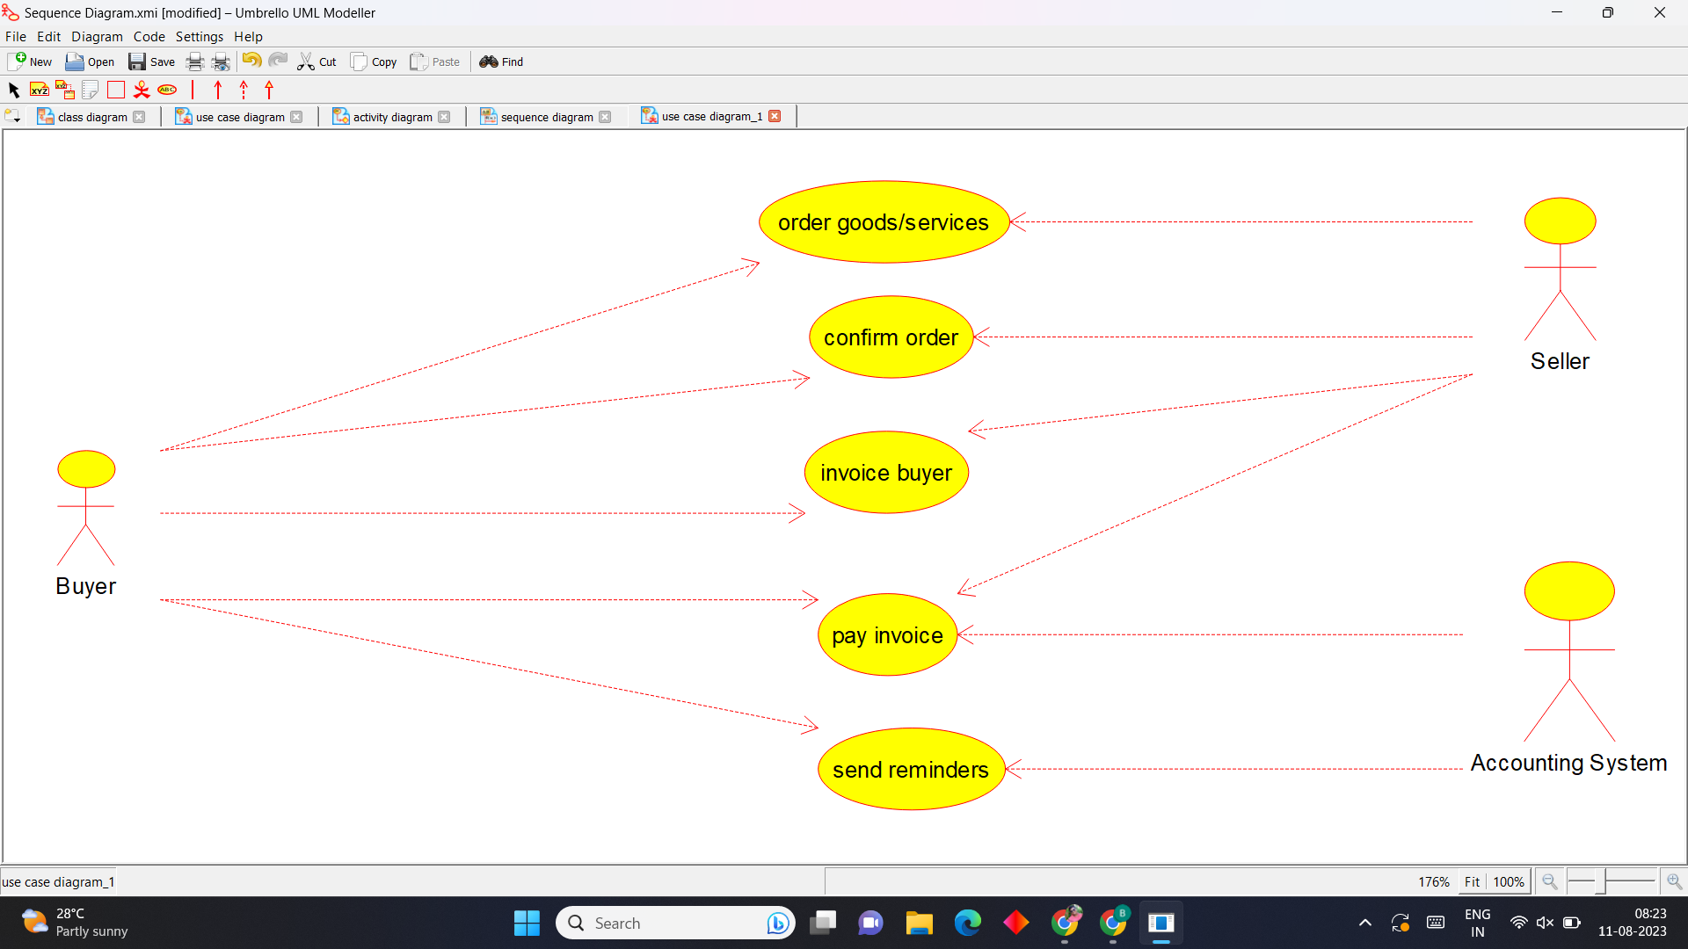

**Activity Diagram**

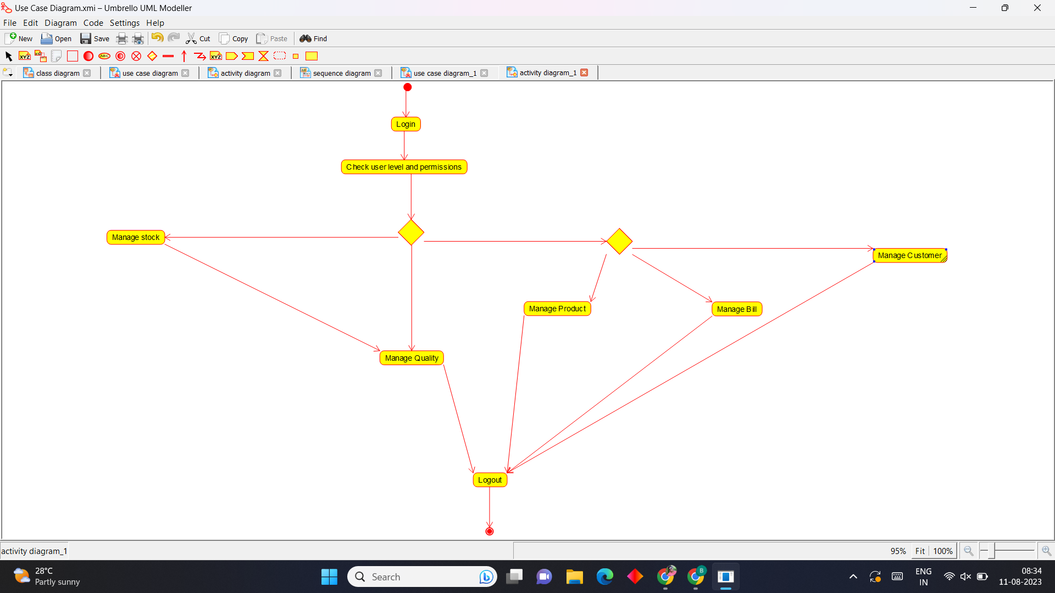

**Sequence Diagram**

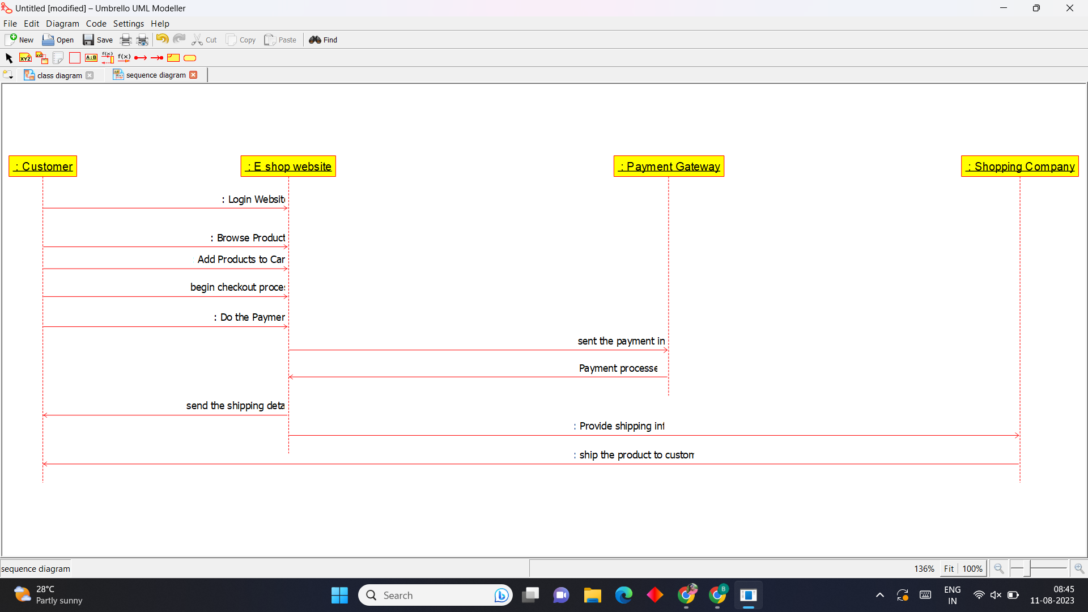

**5)Online Voting System**

**Use Case Diagram**

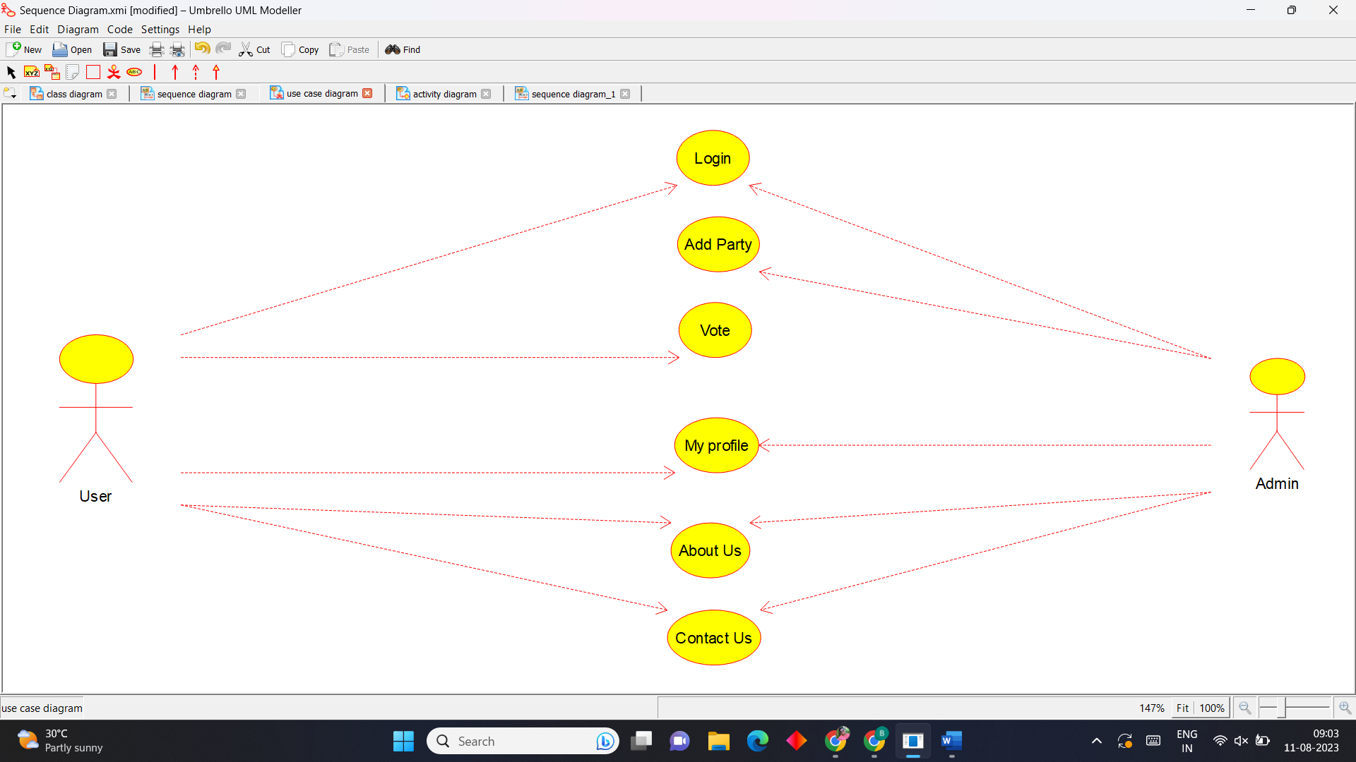

**Activity Diagram**

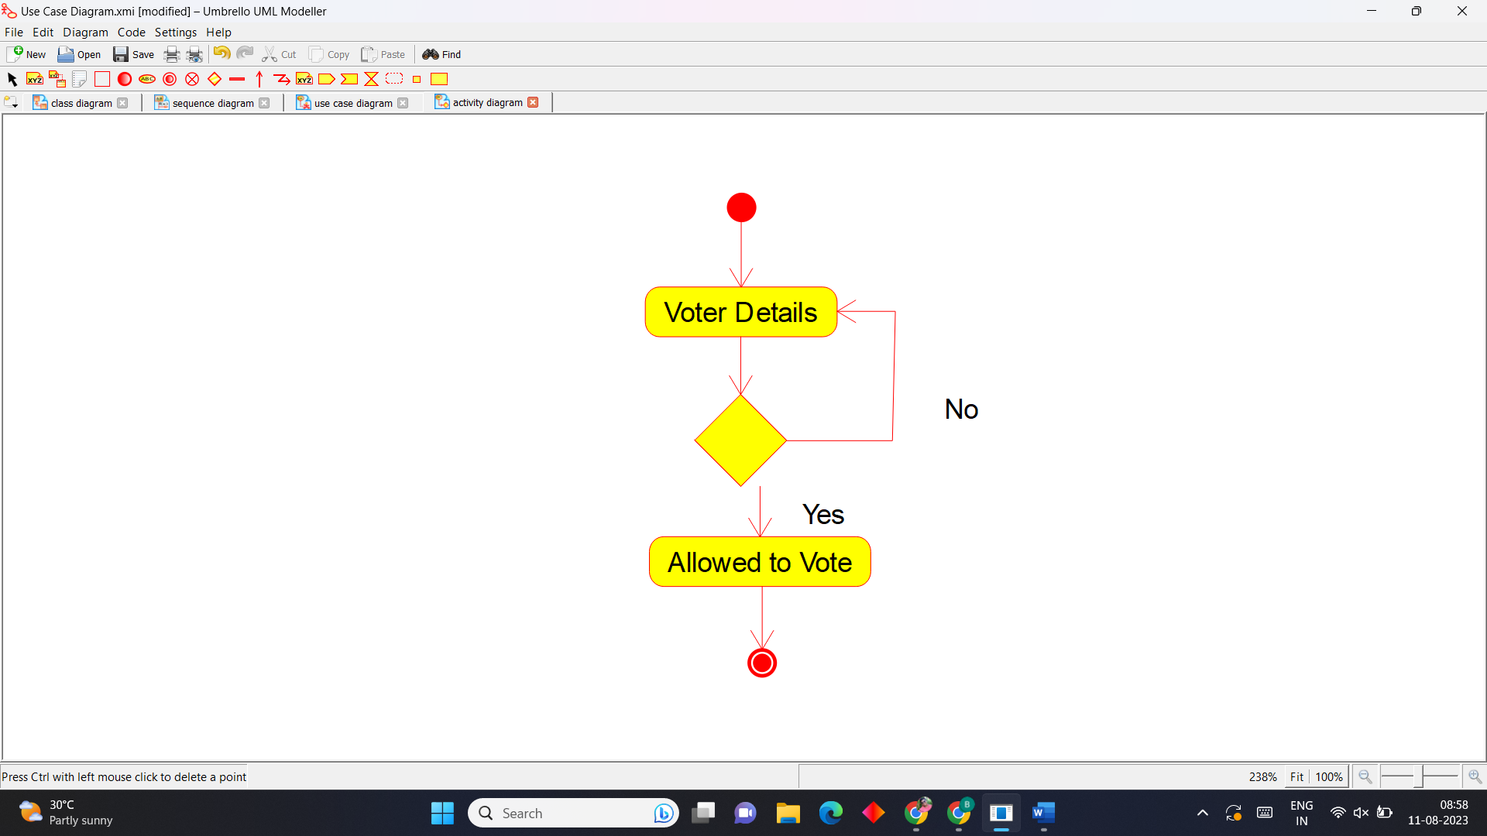

**Sequence Diagram**

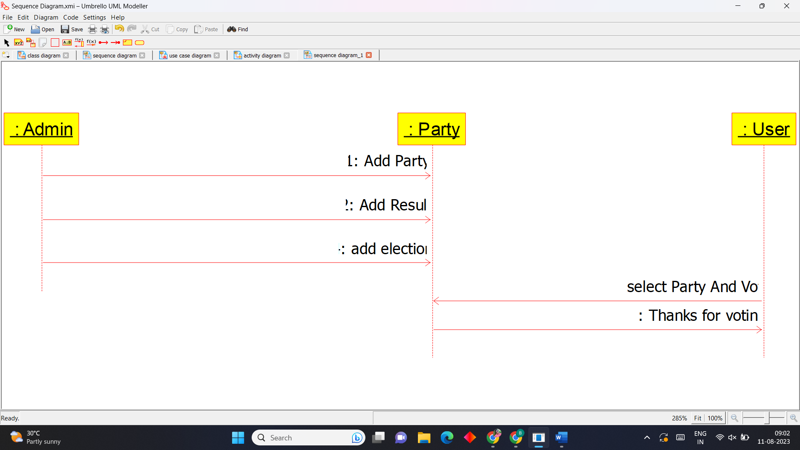

**6)JEWELLERY SHOP MANAGEMENT SYSTEM**

**Use Case Diagram**

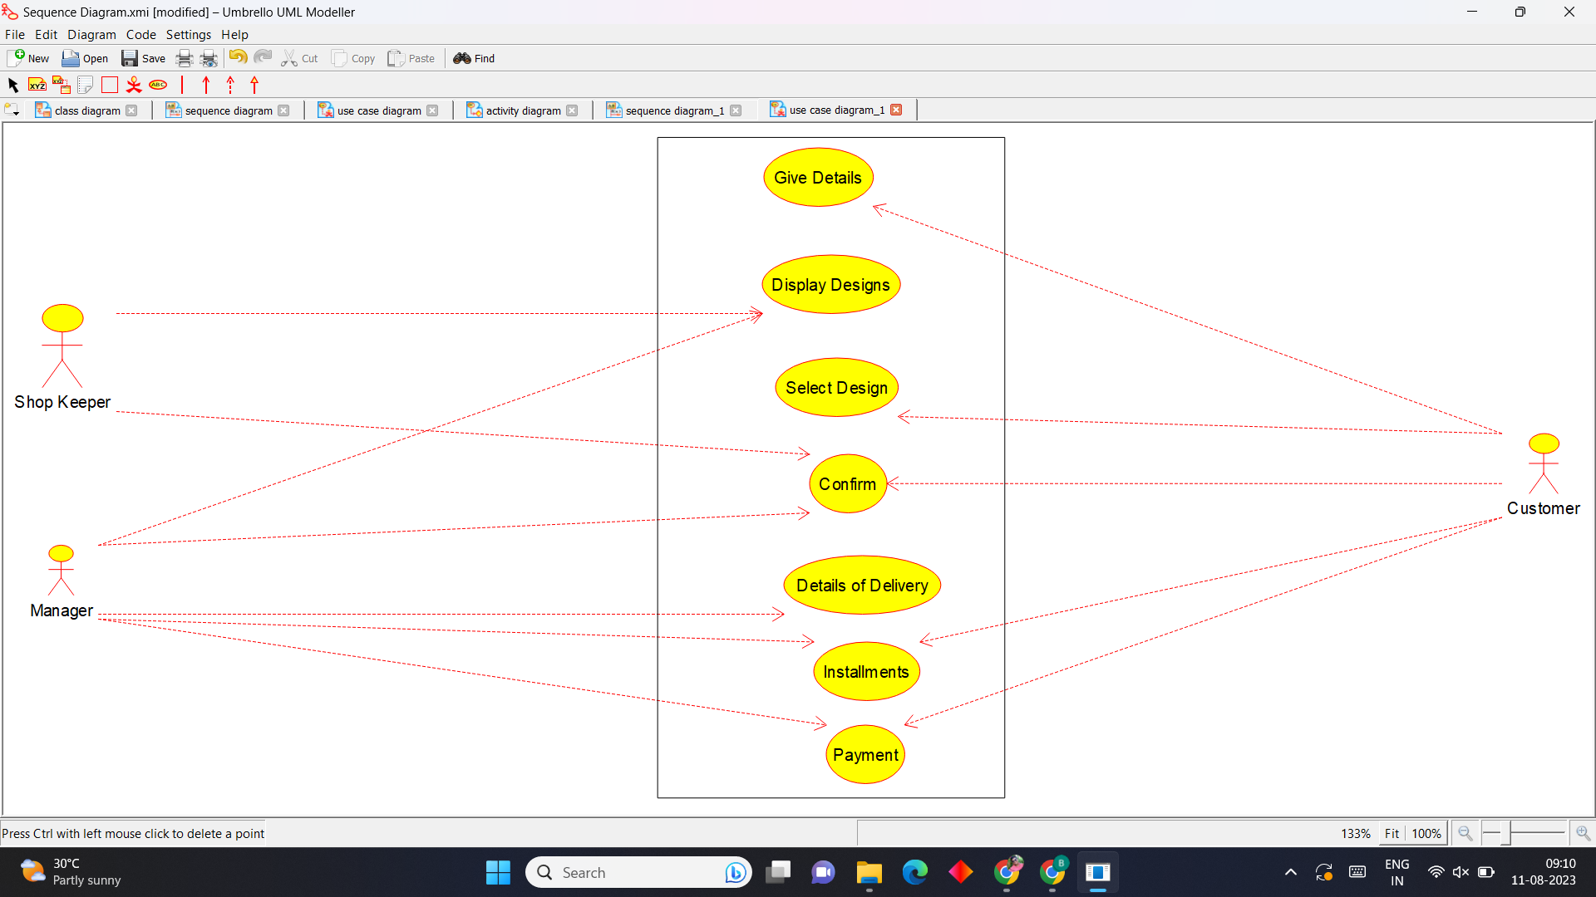

**Activity Diagram**

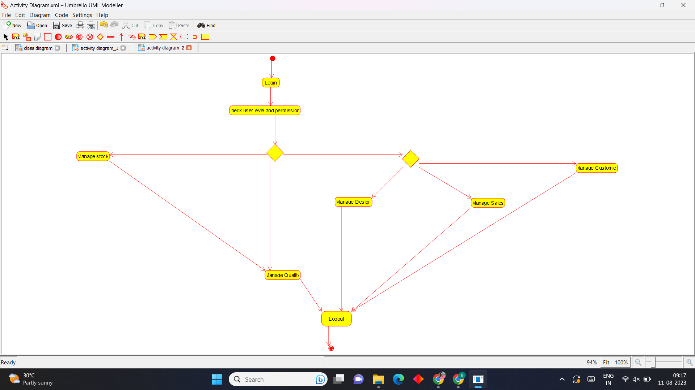

**Sequence Diagram**

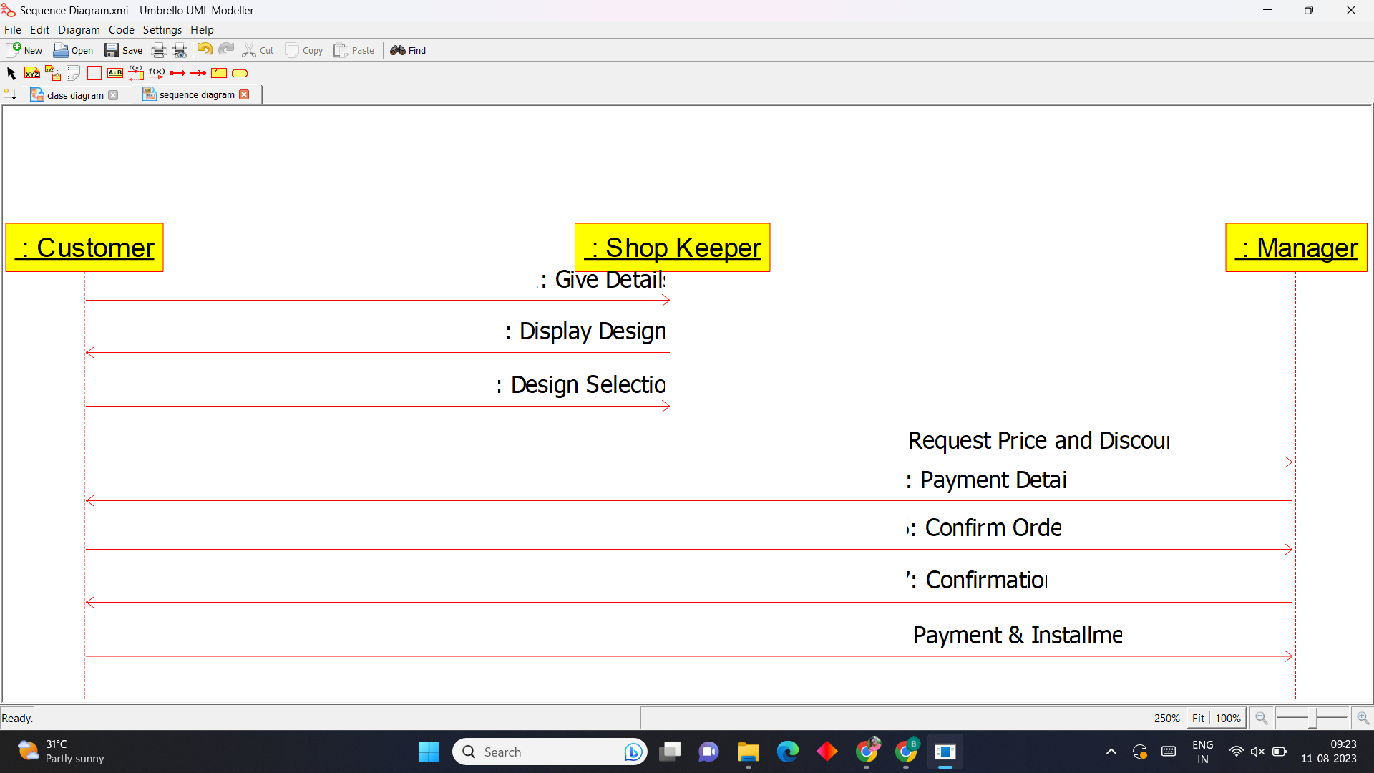

**7)Supermarket Management System**

**Use Case Diagram**

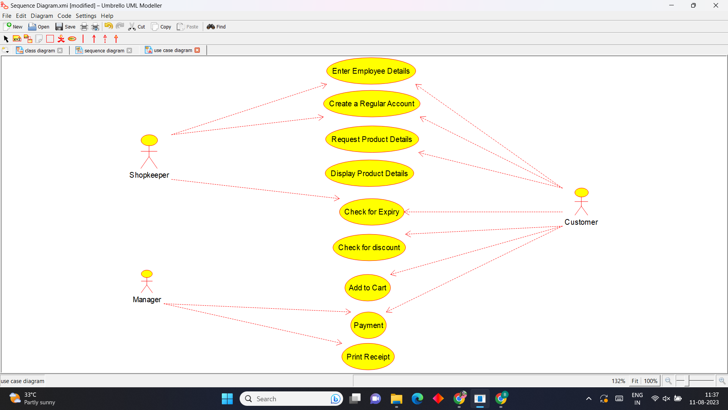

**Activity Diagram**

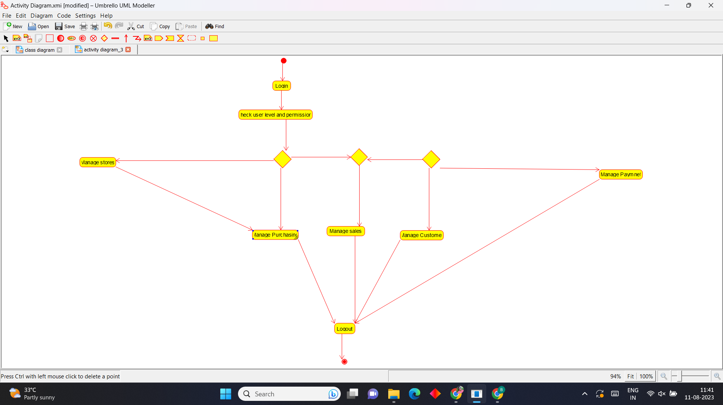

**Sequence Diagram**

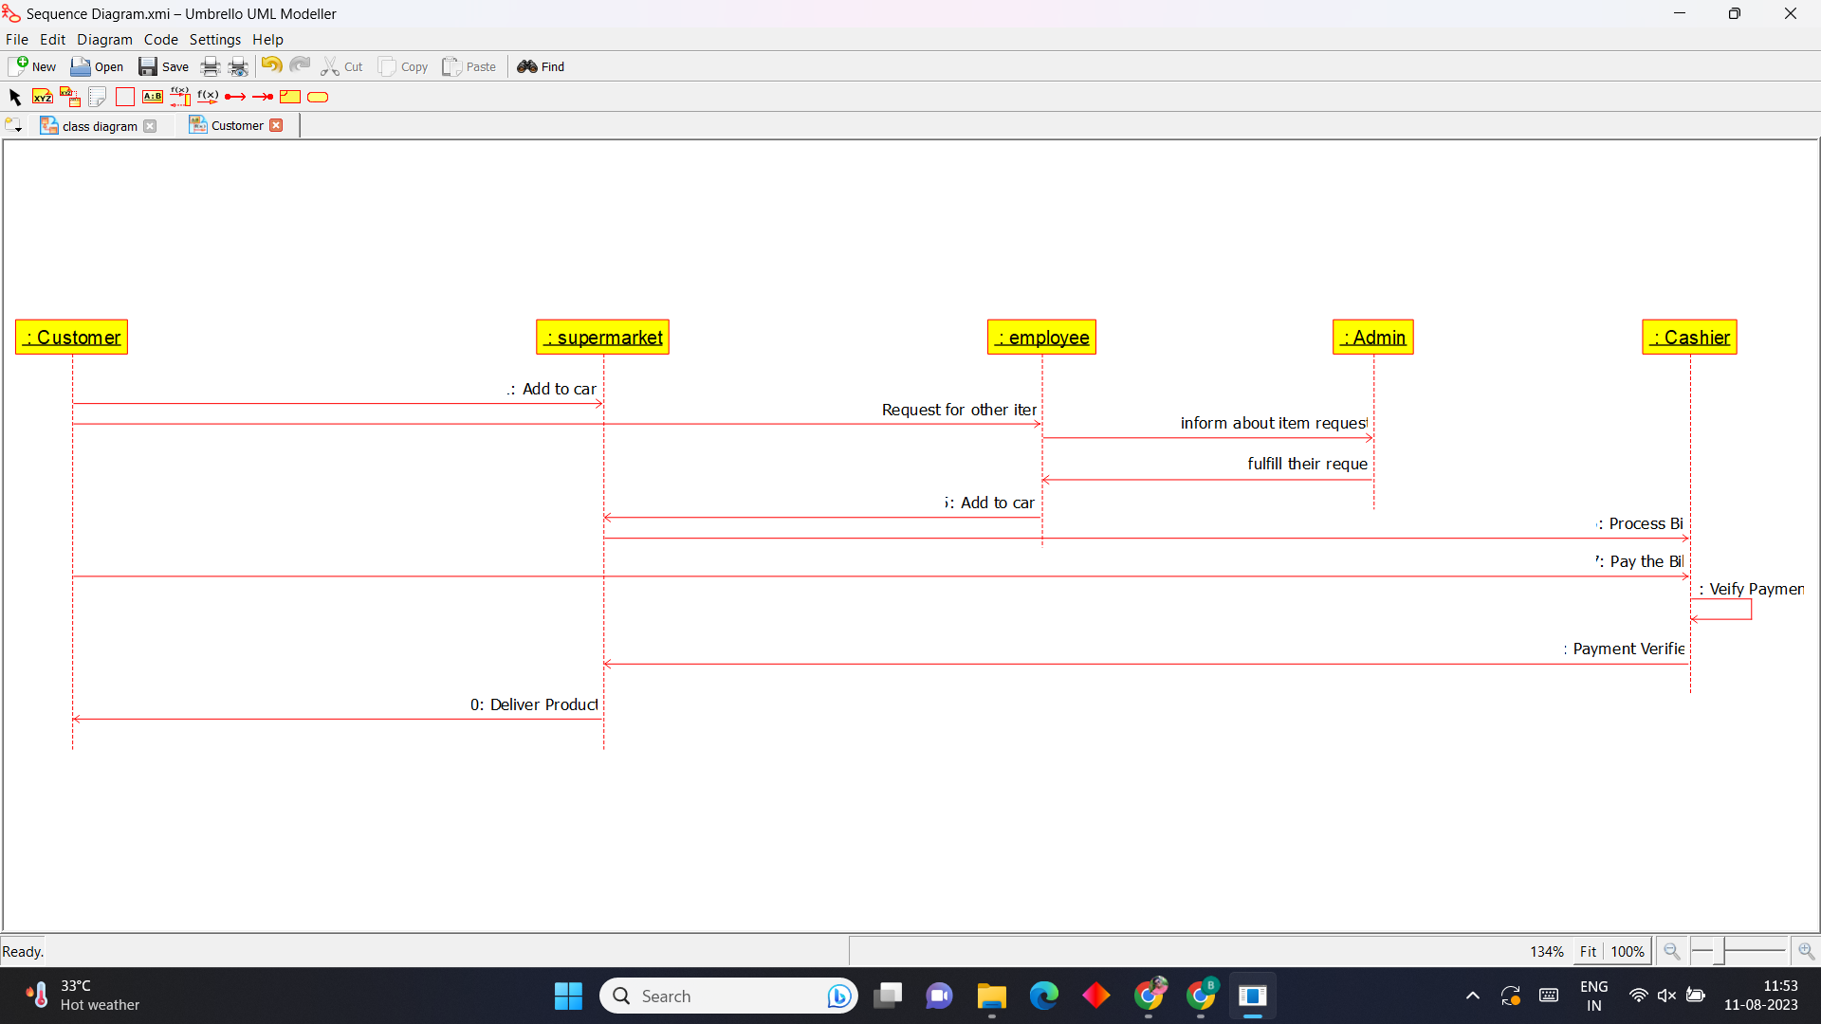

**8)Airline Reservation System**

**Use Case Diagram**

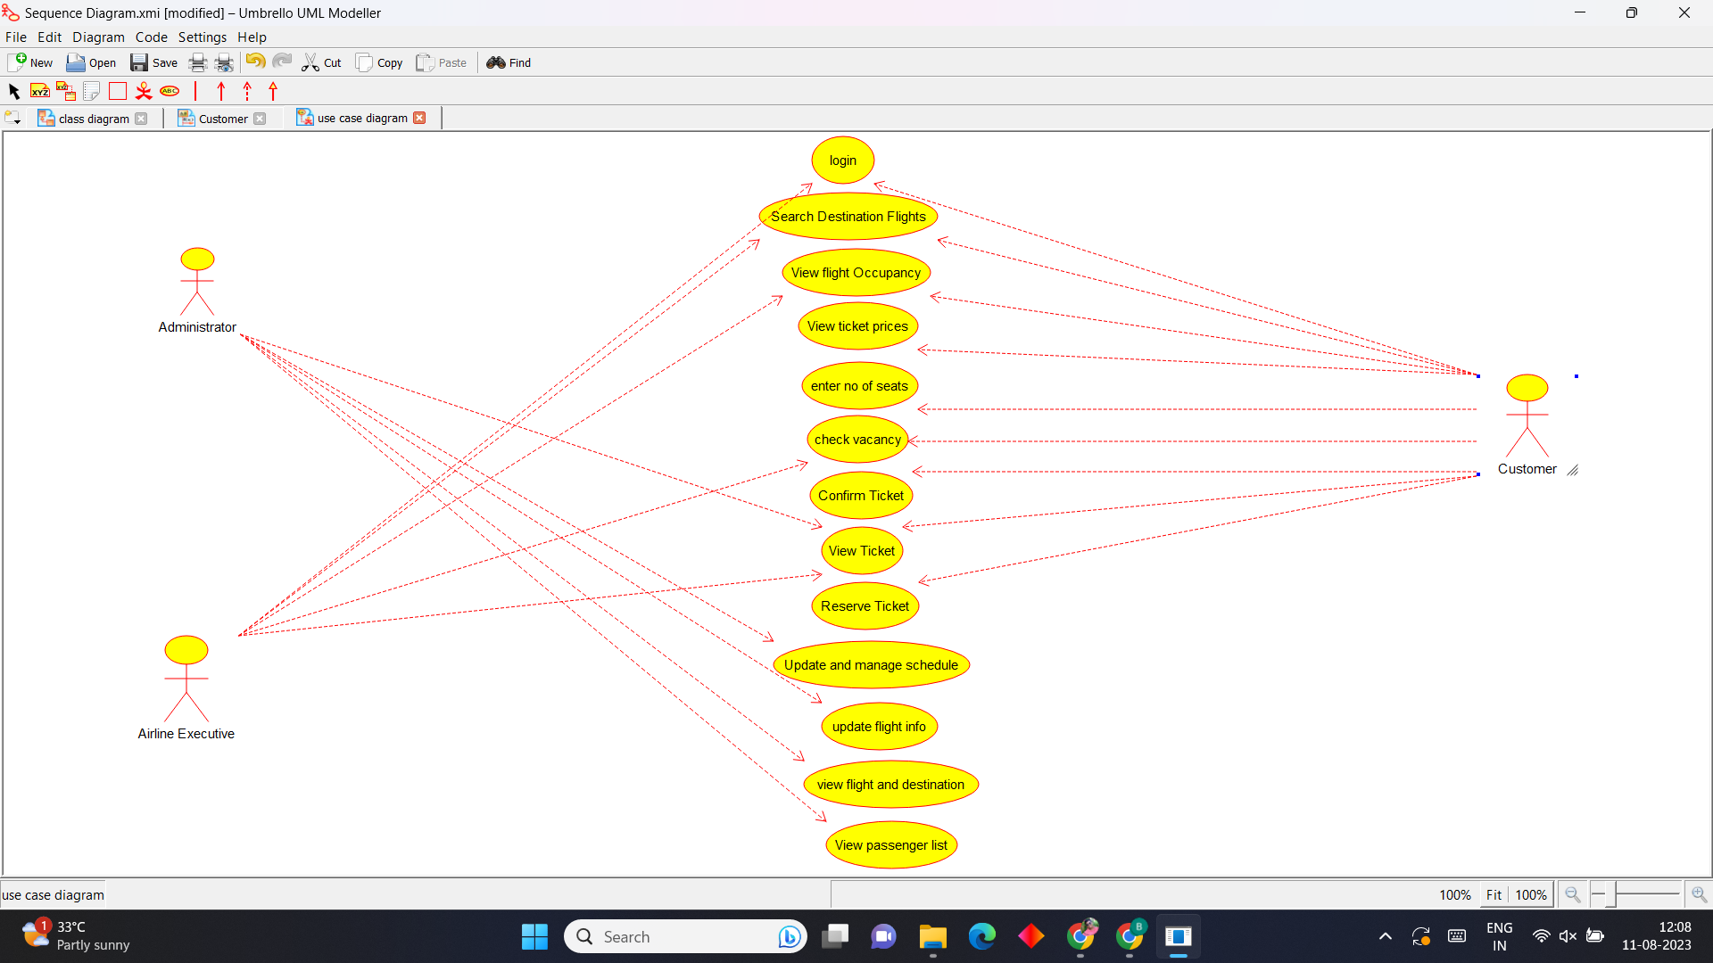

**Activity Diagram**

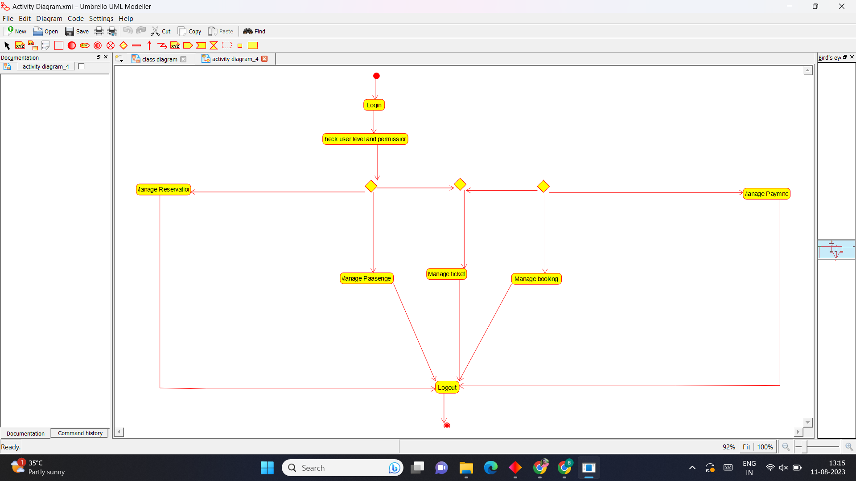

**Sequence Diagram**

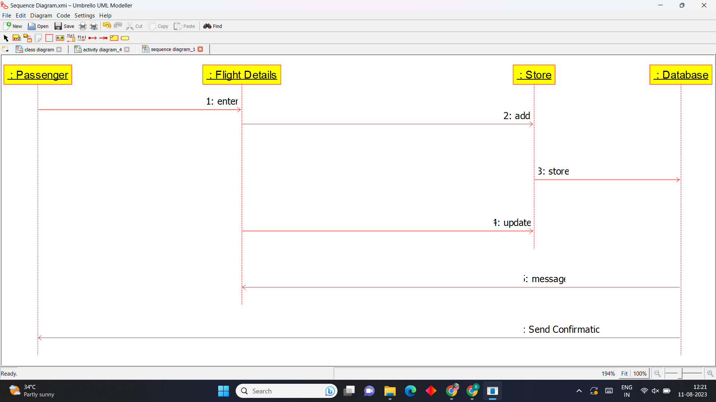

**9)Bus ticket Reservation System**

**Use Case Diagram**

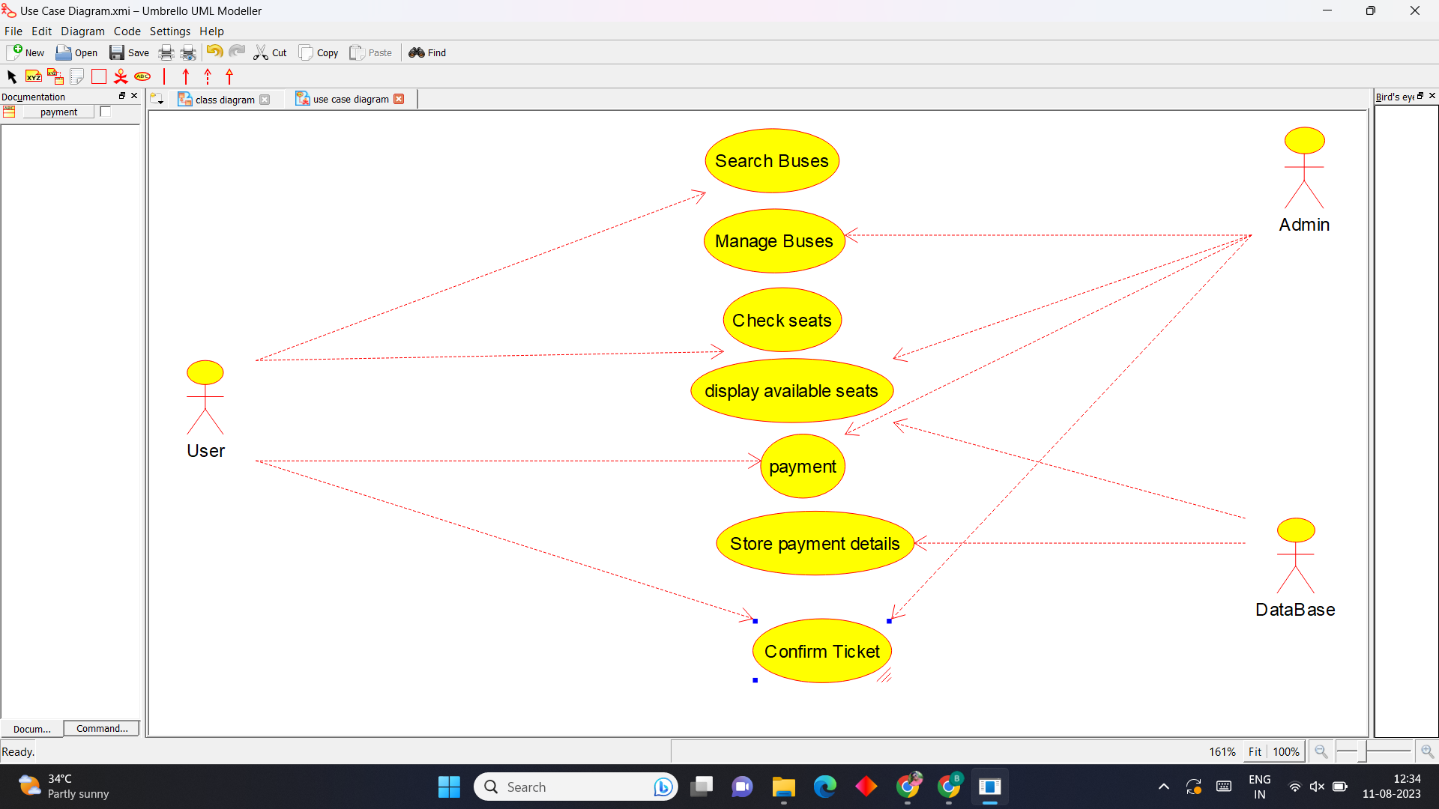

**Activity Diagram**

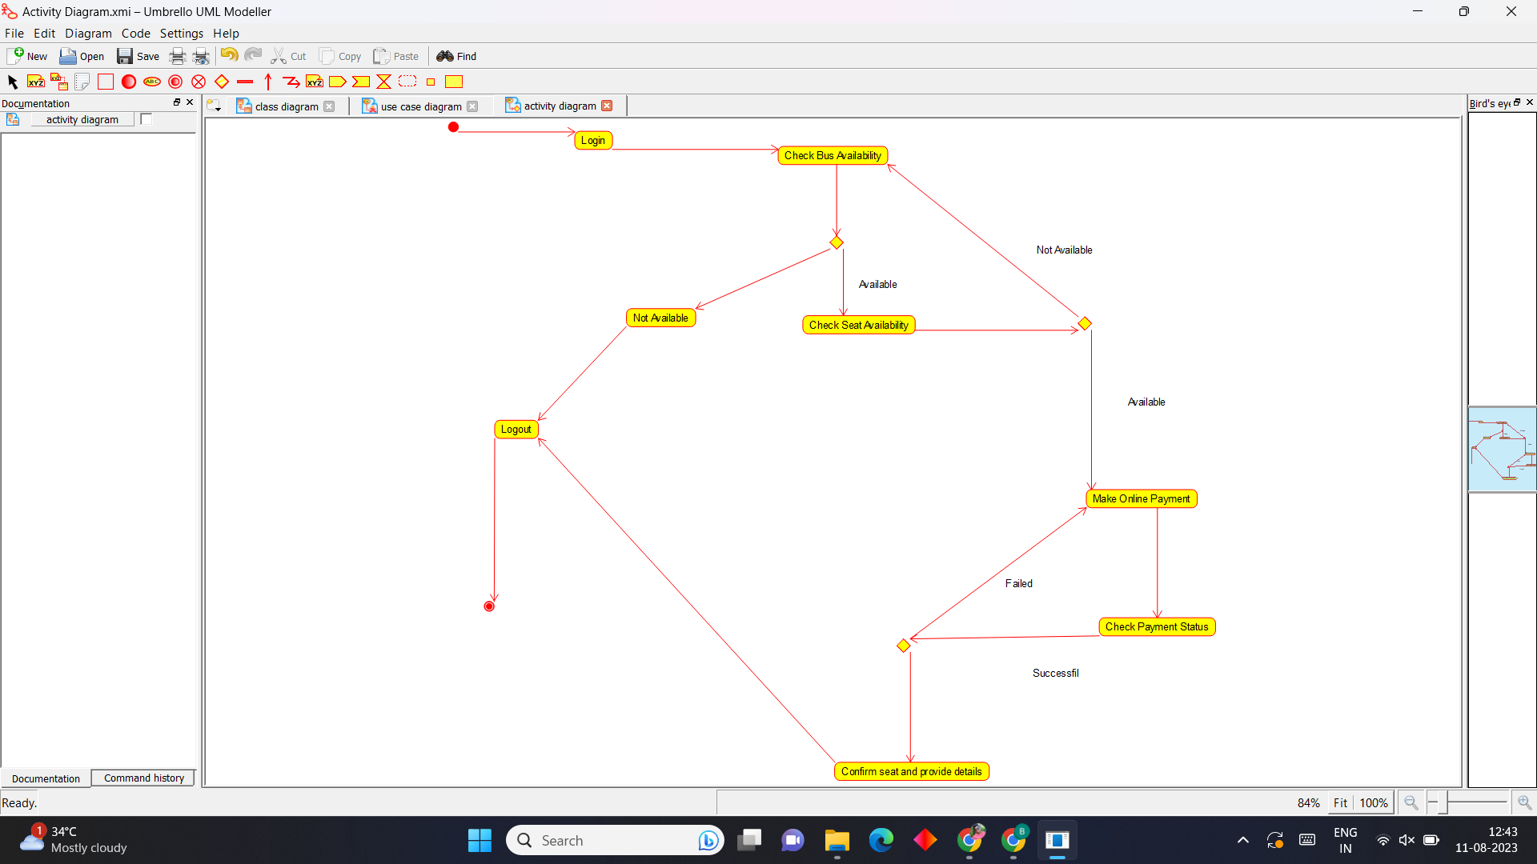

**Sequence Diagram**

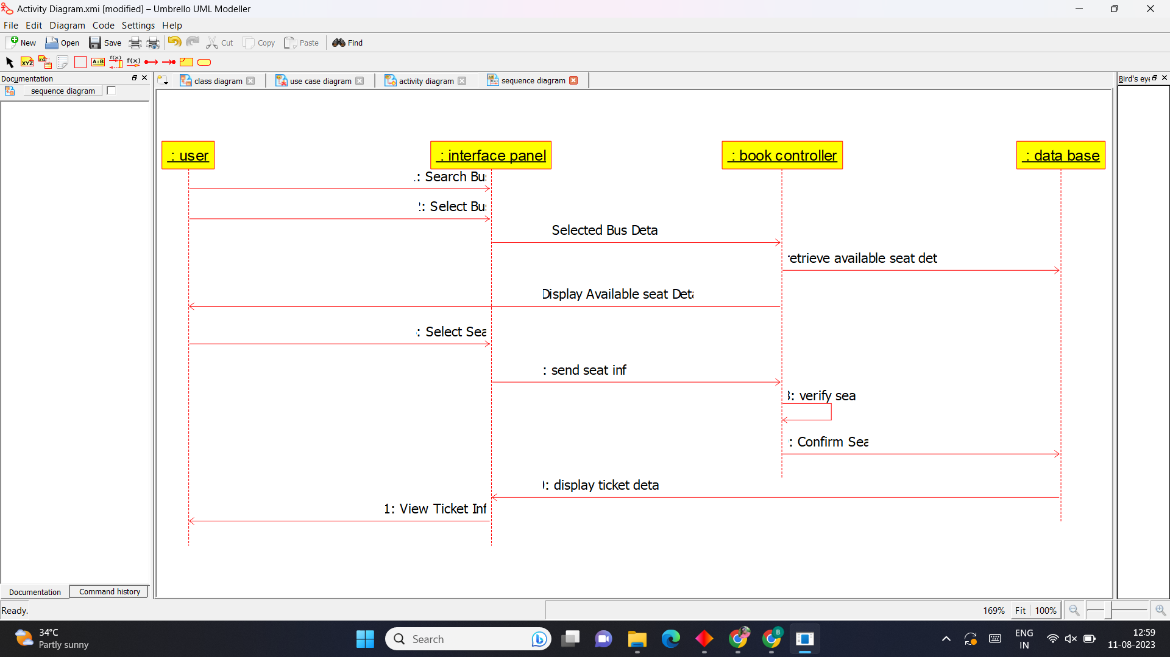

**10)Train ticket Reservation System.**

**Use Case Diagram**

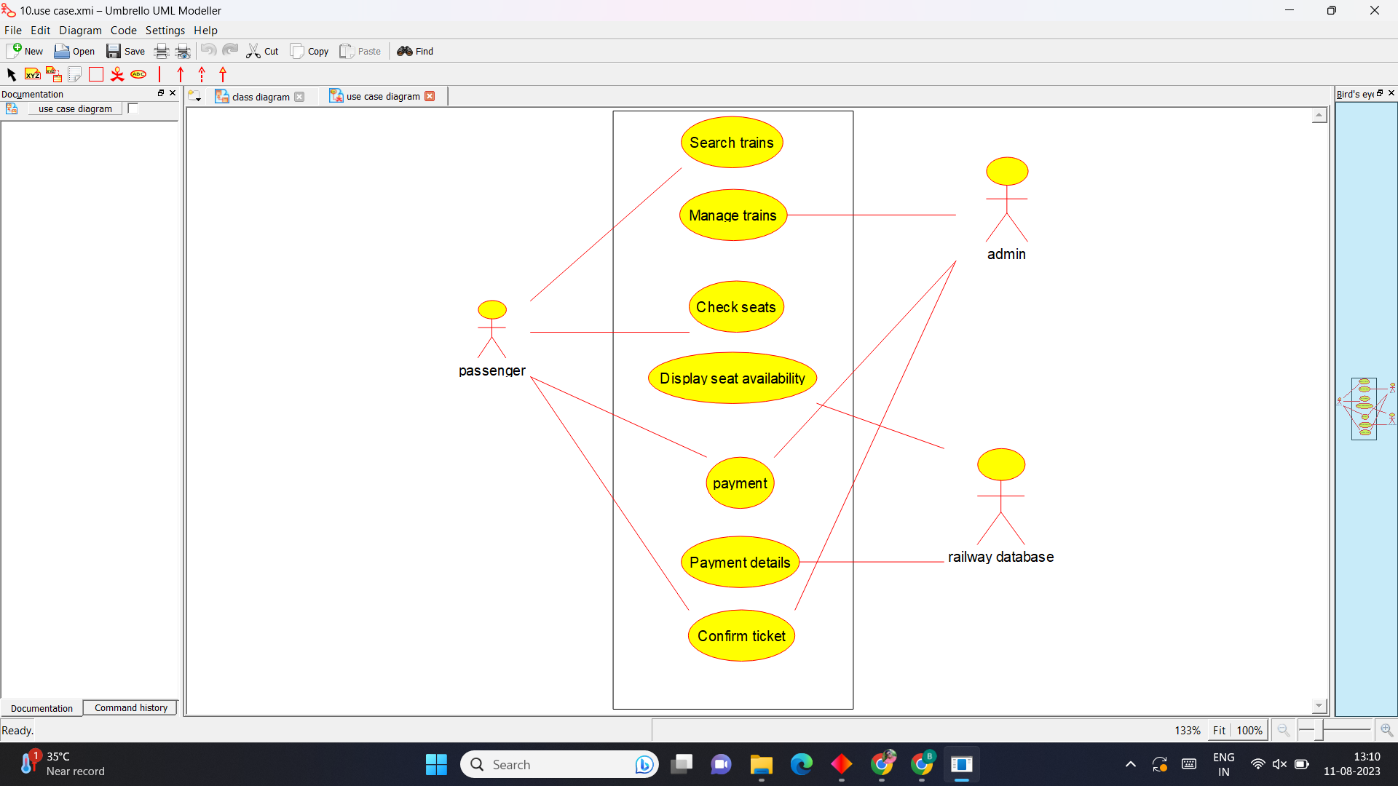

**Activity Diagram**

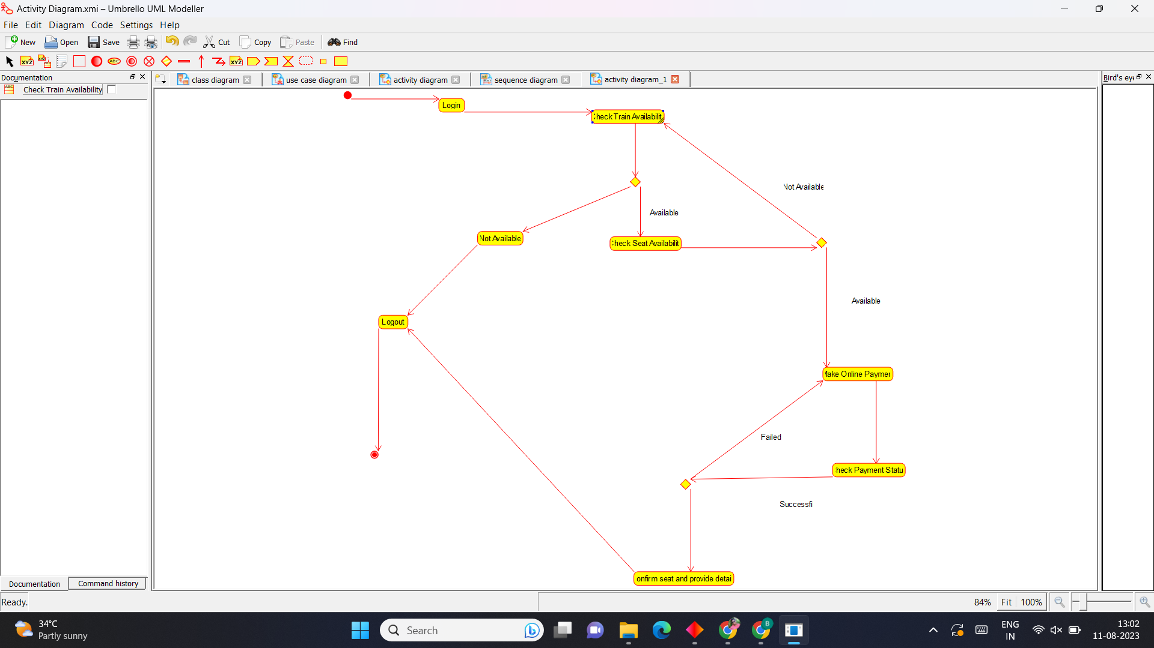

**Sequence Diagram**

